# 4. Probe station

## **4.1 Overview**

### **4.1.1 Probe station setup**

**Microscope**

**Chuck**

**Probe desk**

**Vacuum switch**

**1 = Vacuum switch (For ON or OFF of Vacuum suction)**

**2 = Probe desk (For Micro and RF positioner)**

**3 = Microscope (For Viewing)**

**4 = Chuck (For sample placing)**

### **4.1.2 Microscope**

#### 



**Lenses**

**Knob for focus**





**Camera**

**Knob for Zoom**

### **4.1.3 Chuck**

**Suction hole 1 at the chuck centre**

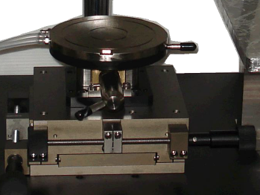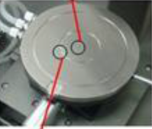



**Pipes for suction**



**Knobs for X and Y movement**

**Knobs for Z movement**

**Suction hole 2 at the inner groove**

* We place sample on the suction hole, vacuum pump suck air through suction hole so sample is stable. 1st place sample then ON vacuum pump then ON vacuum switch of probe station.

### **4.1.4 Micro positioner**

Place the Micro positioner on the probe desk, and let the probe tip be above the sample around 5~7mm. Then place the tip close to the measurement point and use the XY fine-turning knob to adjust the position, and fine-tune z-axis height to confirm the tip position is above the measurement point. Turn the z-axis movement knob clockwise to let the chuck up. Z axis ‘**-**’ for movement toward UP and ‘**+**’ for down.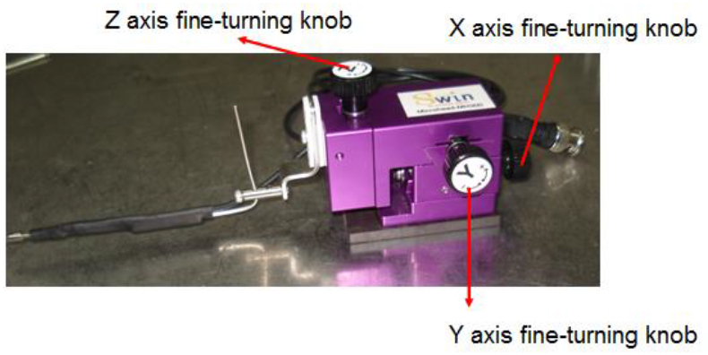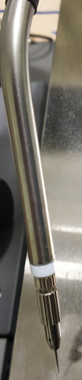

**Optical cable for power supply**

Screw for Tip placement





Fig: Front portion of Micro positioner

Tip

### **4.1.5 Vacuum pump**

## **How to get image from probe station**

* For imaging we use ‘Image view’ software
* 1st connect laptop with probe station camera through USB cable (USB cable is already installed in camera).
* Just double click on ‘Image view’ icon then below window is appears on screen. 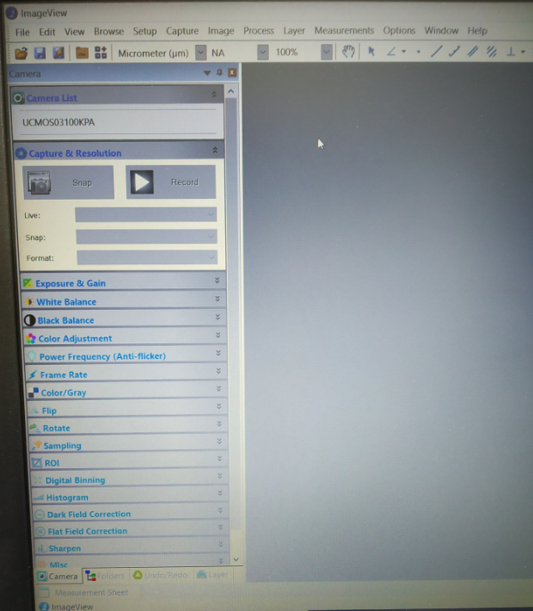
* Then click on this button, after clicking photo is appears on screen. Then Click on ‘Snap’ and save it. 

## **How to supply voltage to Micro positioner and RF positioner**

* Connect Micro positioner to power supply or SMU through optical cable, that cable is already attached with micro positioner (take proper connector)

## **How to put Tip in micro positioner**

Screw for Tip placement





Fig: Front portion of Micro positioner

Tip

* Move screw in clockwise and put ‘Tip’ inside and move screw in anti-clockwise and remove ‘Tip’ .

## **How to ground the chuck**

* Just connect ground terminal of any device to probe station through wire.

## **How to connect SMU with probe station**

* For this we need banana plugs, BNC to banana plug converter and BNC male to female connector because in micro positioner we have BNC male port.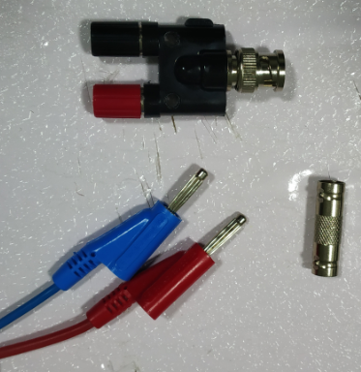



**Banana plug to BNC converter**

**Banana plug**

**BNC male to female connector**

* Put Banana plug in SMU then use banana plug to SMU converter after that use BNC male to female connector then connect micro positioner Optical cable (It have BNC male port).

## **How to start vacuum pump**

* 1st ON main switch of vacuum pump then ON power switch of vacuum pump after that ON vacuum switch of probe station.



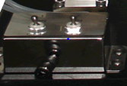



**Vacuum switch**

## **How to touch probe tip to sample**

* 1st put sample on chuck and set magnification and focus by magnification and focus knob respectively.
* Z axis ‘**-**’ for movement toward UP and ‘**+**’ for down. When Tip and sample faw away then only sample is visible because of focus. When both comes together then both are visible. When Tip comes near the sample then Tip and shadow of Tip both are visible move very precisely. When Tip is touch to sample then shadow disappear and if you again move then Tip may be damage. After measurement 1st remove Tip by Z knob movement.

## **How to cut Tip**

# 

**Standard Operating Procedure for**

**Probe Station**

Procedure

1. Holding the sample in place

1. First turn on the probe station light, switch is on the left side of the stand
2. Place your sample on the chuck, make sure the probe tips do not come in the way
3. There are three suction holes (at the centre, on the 1st ring, and on the 2nd ring) on our probe station, but only the centre and the 1st ring holes are connected to the vacuum pump
4. Place your sample on one of the holes
5. Switch on the power supply and the main switch of the vacuum pump, the pump will start, now press the toggle buttons on the probe station to start suction through hole (No. 1 toggle is for centre hole and No. 2 toggle is for the 1st ring hole)

Using the Microscope and camera

1. The microscope has a pair of lenses, a knob to adjust focus, a knob to adjust the zoom and a camera to capture the set up
2. Adjust the focus and zoom, until you get clear picture of the sample through the lens (you can adjust the lens, if you wear spectacles)
3. Now you can use the camera, connect the USB cable of the camera to laptop
4. Open the ‘**ImageView**’ software installed on the lab laptop
5. Click on the button with the label **UCMOS03100KPA**, then click the snap or record to take a picture or record the video of the setup respectively

Connecting Micro-positioner to the SMU or Power Supply

1. Each micro-positioner has a probe connected at the front, each probe consists of an optical cable, and fine-turning knobs (X, Y, Z) to adjust the displacement in X, Y, Z axis
2. Now connect the optical cable to the SMU, to connect we need **BNC male to female connector**, **Banana plug to BNC converter** and the SMU **banana plugs**
3. First connect the **optical cable** to the **BNC male to female connector**, connect the **BNC male to female connector** to the **Banana plug to BNC converter**, finally connect the **Banana plug to BNC converter** to the **Banana plug**

How to touch the probe tip to the sample

1. Make sure all the above stated procedures are completed
2. Place the micro-positioner on the probe desk, such that the probe tip is above the sample
3. The tip won’t be clearly visible on the microscope,
4. Adjust the X, Y, Z fine-turning knob, to touch the sample at the desired position, for Z-knob: turning in ‘+’ direction take the probe in DOWN ward direction, and ‘-’ direction takes the probe in UP ward direction
5. When the tip comes very close to the sample, it will be visible in the microscope and shadow of the tip will be formed on the sample
6. Make very small movement until the shadow disappears that is when the tip has touched the sample, do not move any further, it might damage the tip and the sample
7. After completion, first remove the tip from the sample by Z-knob